**GAME 3011 - Assignment 2 GDD**

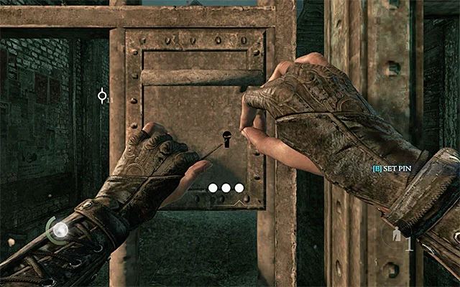

**Theme and Game Inspiration**

The lockpicking mechanics I will be using for this Assignment, is inspired by Thief 4. You have to rotate the lock pick in the rotation that you must align it to the right angle (or close to the angle). However, there is a twist that you have a 60 seconds timer to complete the whole lockpicking minigame.

**Game System and Inputs**

During the Game you have 60 seconds to align 3 parts of the lock. You can rotate the lockpick with the mouse cursor horizontally. When you are around the area that aligns the lock to the angle goal, you can left click the screen and move on to the next part and angle goal point.

To open the minigame panel, you must click the ‘E’ keyboard button and play the lockpicking minigame. When you have completed the game, there will be an exit button that closes the minigame pop-up panel.

**Level of Difficulty**

There are 3 levels of difficulty in the mini-game: Easy, Medium, and Hard. The difficulties determine the area that you are able to click at the goal. But, any difficulty you set the game to, you will always have 60 seconds to complete the minigame.

* Easy: Able to click +/- 15 degrees away from the goal.
* Medium: Able to click +/- 9 degrees away from the goal.
* Hard: Able to click +/- 3 degrees away from the goal.

**How Skills Affect the Game**

The Players skills affect the game in a way that you need good hand eye coordination. You need to move the mouse for the lockpick to rotate at the right angle, then click on it the left mouse button, once you are at the angle goal or close to the right angle goal.